**Kickstart My Chart Findings Report**

1. Given the provided data, what are three conclusions we can draw about Kickstarter campaigns?
   1. The music category is the most successful campaign category with 540 out of a total of 700 campaigns that were completed successfully. This is a 77% rate of success. This biggest contributor to this success rate is the rock sub-category which makes up 260 out of the 540 successful music campaigns. 100% of the rock sub-category campaigns were successful which makes up about 48% of all successful music campaigns.
   2. The Food category is the least successful campaign category with 140 out of a total of 200 campaigns that ended in failure. This is a 70% rate of failure. The biggest contributor to this failure rate is the sub-category Food Trucks which makes up 120 out of the 140 failed music campaigns. About 86% of all failed food campaigns were in the food truck sub-category.
   3. Journalism is the least popular campaign category with only 24 campaigns while the Theater is the most popular with a total of 1393 campaigns.
2. What are some limitations of this dataset?
   1. Our data does not necessarily show us what factors make a campaign more likely to be successful outside of category/sub-category.
   2. Since there is a disproportionate number of campaigns in certain categories such as theater, it is not possible to tell if the category is what drives the state of the campaign. If we had an equal number of sample campaigns from all categories, we could determine a correlation between category and the resulting state of the campaign.
3. What are some other possible tables and/or graphs that we could create?
   1. We could create pie chart to more easily visualize the distribution of states amongst the categories.
   2. Since we have country data, we can use a map chart to show the concentration of campaign states per country. We can tell at a glance which country had the highest concentration of successful, failed, canceled, or live campaigns.

Bonus Statistical Analysis

1. Use your data to determine whether the mean or the median summarizes the data more meaningfully.
   1. The median summarizes the data more meaningfully since our data is very spread out as indicated by the minimum and maximum values for both Successful and Failed campaigns as well has the standard deviation. Higher values like the max 26457, skew the mean to the right and does not accurately represent the central point of our dataset. Since our data is not normally distributed, the median would be a more meaningful summary of our data.
2. Use your data to determine if there is more variability with successful or unsuccessful campaigns. Does this make sense? Why or why not?
   1. There is more Variability for successful campaigns as indicated by the significantly larger variance and standard deviation.

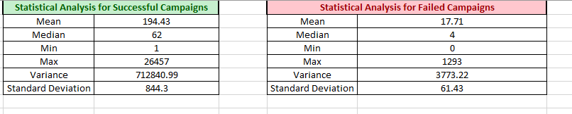

* 1. This makes sense because usually successful campaigns have a much higher number of backers. Since it usually requires a large number of backers for a campaign to be successful, it makes sense that there is a large variance with the minimum number of backers being 1 and the max being 26,457. Failed campaigns usually fail due to the lack of total number of backers. The minimum to maximum range for failed campaigns is 0 to 1293 which explains the smaller degree of variance.